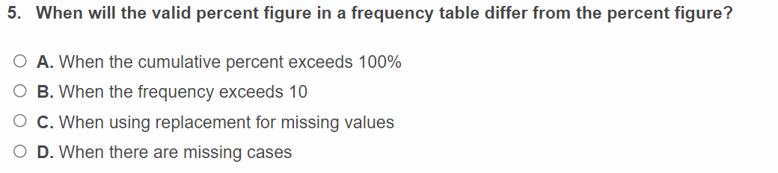
D. when there are missing cases
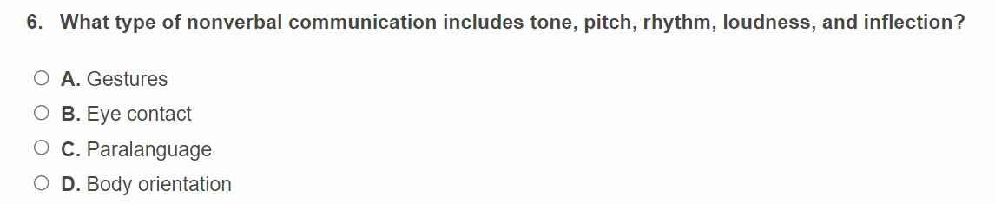
C. Paralanguage
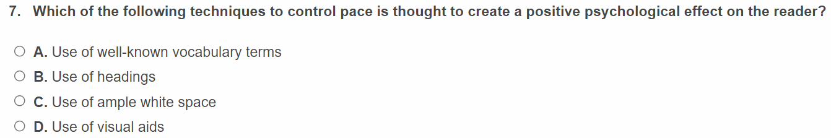
D. Use of visual Aids
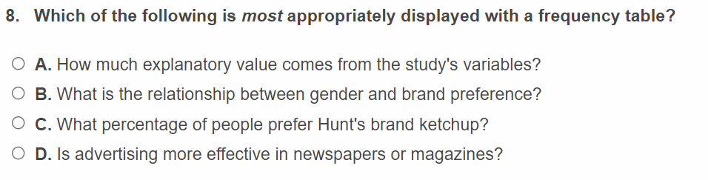
C. What percentage of people prefer hunt’s brand ketchup
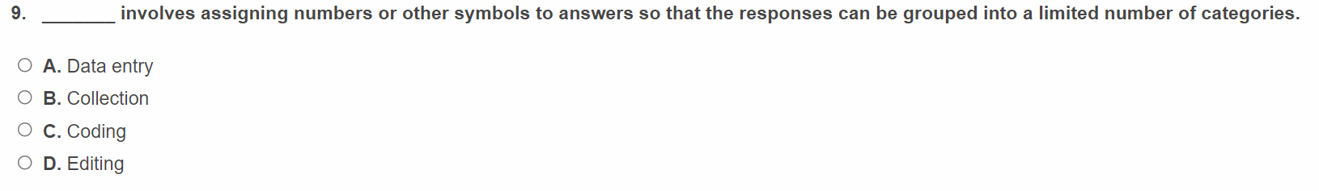
C. coding
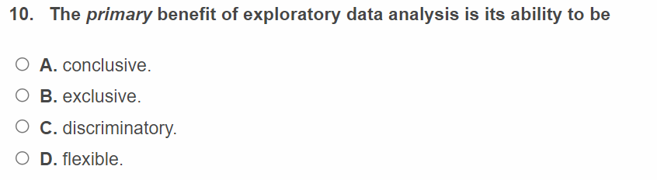
D. flexible
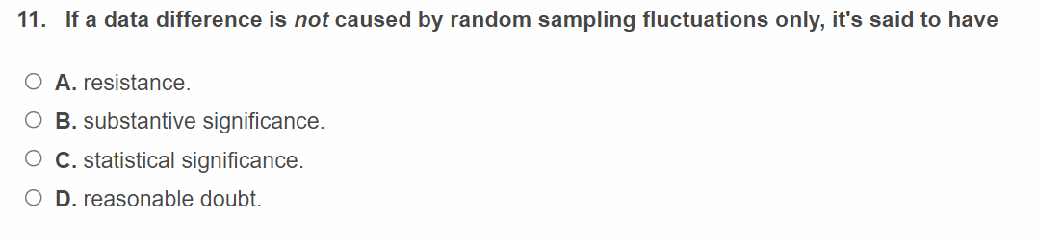
C. Statistical significance
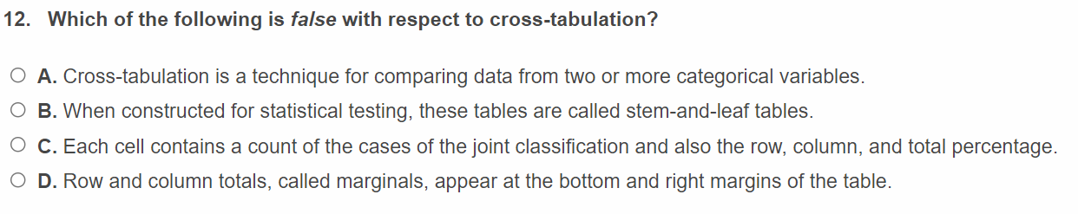
B. when constructed for statistical testing, these tables are called stem and leaf tables
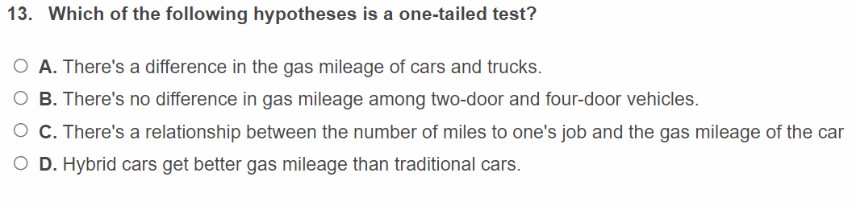
D. Hybrid cars get better gas mileage than traditional cars
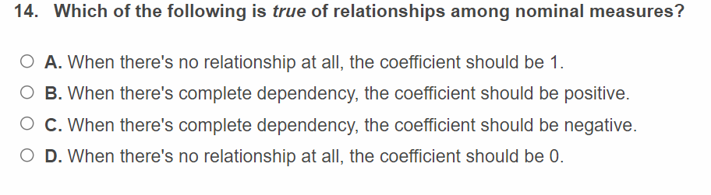
D. when there is no relationship at all, the coefficient should be 0
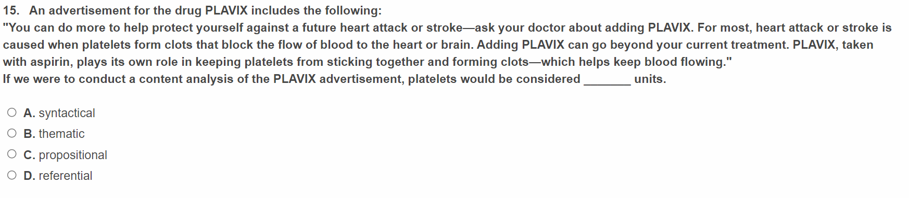
C. propositional

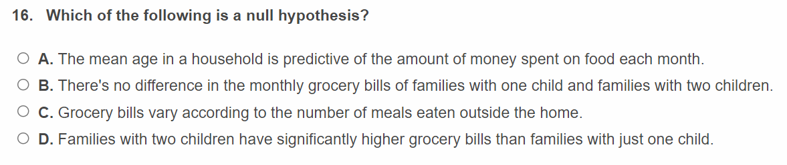
B. there is no difference in the monthly grocery bills of families with one child and families with two children
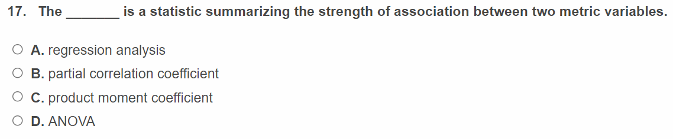
C. product moment coefficient
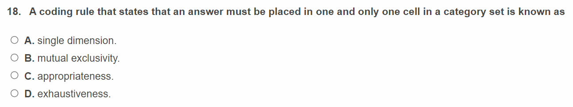
C. Appropriateness
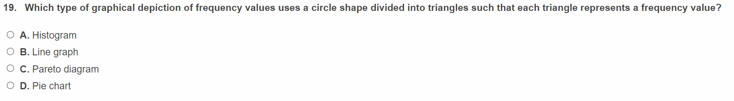
D. Pie chart

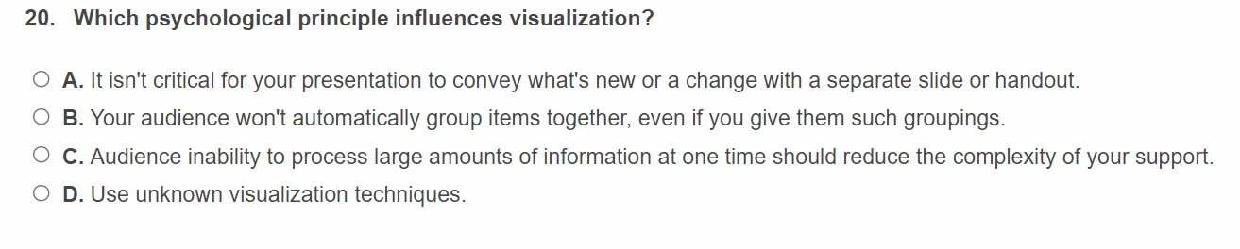
C. Audience inability to process large amount of information at one time should reduce the complexity of your support

